All of the HIMA products mentioned in this manual are trademark protected. Unless noted otherwise, this also applies to other manufacturers and their respective products referred herein.
HIQuad®, HIQuad® X, HIMax®, HIMatrix®, SILworX®, XMR® and HICore® are registered trademarks of HIMA Paul Hildebrandt GmbH.
All of the technical specifications and information in this manual were prepared with great care and effective control measures were employed for their compilation. For questions, please contact HIMA directly. HIMA appreciates any suggestion on which information should be included in the manual.
Equipment subject to change without notice. HIMA also reserves the right to modify the written material without prior notice.
Registered customers can download the product documentation from the HIMA Extranet.

© Copyright 2024, HIMA Paul Hildebrandt GmbH
All rights reserved.

Contact
HIMA Paul Hildebrandt GmbH
P.O. Box 1261
68777 Brühl, Germany
Tel.: +49 6202 709-0
Fax: +49 6202 709-107
E-Mail: info@hima.com
Document designation | Description
SILworX Plugin read_diagnostic D  Rev. 1.0 (2409) | German original document
SILworX Plug-In read_diagnostic E  Rev. 1.0 (2413) | English translation of the German original document

Table of Contents

1 SILworX Plug-Ins (Option Subject to License) 5
2 Configuring Plug-Ins 6
2.1 Creating the SSL Certificate and Key 6
2.2 Completing the «settings.ini» 7
3 Plug-In-Registration 9
3.1 Avoiding Errors During Plug-In Registration 9
4 Starting Plug-Ins 10
4.1 Plug-In Hash Files 10
4.2 Completing the «customplugins.json» 11
5 Functionality of the Plug-In «read_diagnostic.exe» 12

- SILworX Plug-Ins (Option Subject to License)
Starting with version 14, SILworX can be equipped with plug-ins to enhance its functionality. Plug-ins are non-safety-related applications that interact with SILworX, but are not contained in the SILworX development environment and are not certified along with SILworX.
Plug-ins enable users to create additional functions according to their own needs or to make these available to others. The prerequisite is that the necessary licenses exist. Plug-ins created by the customer can be used with the Plug-In Feature license in combination with the SILworX API license. Use of the license-free plug-ins provided by HIMA requires only the SILworX license.
Plug-ins run as independent processes in a memory area separate from SILworX and interact with SILworX via the SILworX API and WebSocket interfaces. Plug-ins can be integrated interference-free and do not impair the safe SILworX functions in any way.
Because plug-ins are not an integral component of SILworX, they must be configured in the settings.ini file. To this end, the settings.ini file includes the [Plugin_Server] category. When started, SILworX checks whether the registered plug-ins exist and readies them so the functionality they offer is available in SILworX. SILworX starts the plug-ins listed in settings.ini under PluginNames automatically. The sequence of the plug-in names determines the processing priority of the plug-ins in the event of simultaneous triggering.
Plug-ins evaluate predefined triggers provided by SILworX as well as user-specific triggers and execute the functions required by the user. The actions triggered in SILworX by plug-ins are logged in the logbook. A separate area to the right of the API information in the Status Bar displays information about the plug-in feature.
The plug-ins that are started have no separate user management. Authentication takes place when the project is opened in SILworX. The user session this creates is also available to the plug-ins and the SILworX API.
When the plug-in feature has been started, you can use the Plug-In Information menu function in the SILworX Help menu to open a dialog box. The dialog box contains the two lists, Configured Plug-Ins and Registered Plug-Ins. The dialog box shows the actions with which a plug-in in SILworX is linked and which triggers from SILworX or to SILworX are registered.

Summary:
- Plug-ins are SILworX add-ons that can be created by users themselves.
- Plug-ins are based on programs or scripts, possibly with additional files, that are configured in SILworX.
- Plug-ins are independent modules that run in separate processes.
- Plug-ins are started automatically along with SILworX.
- Plug-ins have access to SILworX via the SILworX API functions.
- Plug-ins require a Plug-In Feature license as well as a SILworX API license.
- Plug-ins can react to predefined triggers as well as user-defined triggers.
- The execution of plug-ins is displayed in the SILworX status bar.

- Configuring Plug-Ins
To use SILworX plug-ins requires that you save the desired plug-ins to a drive that is accessible to SILworX and configure them in the settings.ini file. You also require a Plug-In Feature license, a SILworX API license and a SILworX API certificate. Access to the SILworX API is only possible via SSL (TLS 1.2 or TLS 1.3).
The use of SSL requires a valid certificate and the associated private key. The paths to these files must be entered in the settings.ini file in the category [API_Server]. Using plug-ins in combination with the SILworX API requires that the configuration parameter Enabled of the category [API_Server] in the settings.ini is set to TRUE.
When starting, SILworX imports various plug-in configuration parameters from the settings.ini file, which are grouped in the category [Plugin_Server]. After this, SILworX checks the integrity of the registered plug-ins based on the hash codes. If the result of the integrity check is positive, SILworX makes the plug-in functions available.
The names of the plug-ins to be used in SILworX must be present in the PlugInNames list separated by commas. If several plug-ins respond to a certain trigger, their sequence in the PlugInNames list determines the order in which the plug-ins are executed.


A maximum of 254 plug-ins can be registered.

If PlugInNames contains plug-in names that occur more than once, the duplicates are rejected during the import of the plug-in configuration and SILworX reports an error.


The plug-in names are defined in the metadata of the plug-ins. They can differ from the names of the files used for the plug-ins.

The plug-ins listed in PluginNames must be executable programs (*.exe) and, to protect against unauthorized tampering, each of these plug-ins must be configured in the hash file customplugins.json.


SILworX installs several HIMA plug-ins and enters their names as PluginNames by default. You can supplement this list at any location with your own PluginNames. The API server must also be Enabled to allow use of the HIMA plug-ins.

After initialization, SILworX automatically starts all of the plug-ins configured in PluginNames. Doing so requires that the appropriate hash codes for the plug-ins listed in PluginNames are present in customplugins.json. The data paths are also taken from customplugins.json. SILworX issues messages to the logbook if plug-ins cannot be started.
  - Creating the SSL Certificate and Key
To use the SILworX API, you need an SSL certificate in the PEM format, which you must create yourself. In addition to the certificate, you also need the corresponding private key in the PEM format that was created with the RSA algorithm without a passphrase.
The certificate and key must be entered in the SILworX settings.ini file.



Observe the period of validity of the SSL certificate!
When you create a new SSL certificate, you can define its period of validity in days. HIMA recommends limiting the period of validity to 365 days or less. Some clients (e.g., current browsers) do not accept any self-signed certificates with a validity period of greater than 365 days.

To create a valid certificate
- Select in SILworX Extras, Create SILworX-API certificate from the main menu. The Create SILworX-API certificate dialog box appears.
- Enter a path for the destination directory and the certificate name in the Filepath - Certificate field or use the button on the right-hand side, next to the field, to specify the path and name in a dialog box.
- Enter a path for the destination directory and the key name in the Filepath – Key field or use the button on the right-hand side, next to the field, to specify the path and name in a dialog box.
- If required, fill in the optional fields with your data.
- Click Create to confirm the action.
  - Completing the «settings.ini»
To configure the SILworX API and the plug-ins, you must complete the following entries to the settings.ini file.
- Open the settings.ini file in the SILworX progam data directory %ProgramData%\SILworX_vXX.X.0 Rxxxx\settings\, for example C:\ProgramData\SILworX_v14.0.0 R2908\settings\settings.ini, with a text editor.
- Search in the settings.ini file for the entry [API_Server]. If this entry does not exist, append it to the end of the file.
- The following entries are required under [API_Server], and you must complete them as needed.
Enabled=true
IpAddress=::1
Port=444
ServerCertificate=Absolute path to the certificate file
ServerPrivateKey=Absolute path to the key file
- Search in the settings.ini file for the entry [Plugin_Server]. If this entry does not exist, append it to the end of the file.
- The following entries are required under [Plugin_Server], and you must complete them as needed.
PluginNames=List of plug-ins names separated by commas


API requests via localhost
Plug-ins use the domain name localhost to communicate with the SILworX API. The Windows operating system resolves localhost first to IPv6 before an IPv4 localhost address is used. This can lead to delays of a few seconds in the execution of each API call. As a workaround, the SILworX API server should be configured to the IPv6 localhost address. To do this, enter the parameter IpAddress=::1 in settings.ini.



Error: Port 443 is not available
The SILworX API requires a free network port; for SSL this is network port «443» by default. If this port is already occupied by another application, SILworX displays an error message at startup that port 443 is not available and therefore the API server cannot be started. As a workaround, the API server must be configured to a different network port. To do this, enter the parameter Port=444 (or any other free port number) in settings.ini.

Example for the «settings.ini»


...
[API_Server]
Enabled=true
IpAddress=::1
Port=443
ServerCertificate=C:\Plugins\Certificates\api_cert.pem
ServerPrivateKey=C:\Plugins\Certificates\api_key.pem
SessionTimeout=240 (*)
[Plugin_Server]
PluginNames=hima.ssl_certificates_creator, read_diagnostic
Development=PlugIn_1
Timeout=119 (*)
Port=8400 (*)

(*) Optional
SessionTimeout = time in seconds
Session Timeout / TImeout: The default value is 120 seconds. Change this parameter if another value is needed.

- Plug-In-Registration
In the registration that follows a successful WebSocket connection set-up, the plug-ins log in to SILworX with their names, the metadata and their required triggers. This requires that the plug-ins be correctly configured with their names in settings.ini.
Plug-ins log in after they are started by means of messages, which they send to SILworX. If the registration was successful, messages with the file path of the plug-ins are written to the logbook. Also the hash codes of the plug-ins are shown.
  - Avoiding Errors During Plug-In Registration
If the registration was not successful, an error message is displayed in the logbook with an indication of the cause of the failed registration. To avoid errors, observe the following notes:
- Multiple registration of plug-ins
No duplicate names may occur in the configuration parameter PluginNames of settings.ini.
- Inadmissible registration of a plug-in
The plugin name defined in the metadata of a plug-in must be listed in the configuration parameter PluginNames of settings.ini. This plugin name must also be assigned as a value to the plugin_name key in customplugins.json.
- Maximum number of plug-ins
In SILworX, you can register a maximum of 254 plug-ins simultaneously.
- Maximum number of triggers
The maximum number of 20 trigger entries for the Extras menu and 100 trigger entries for the total of all context menus must not be exceeded.
- Incorrect formatting of hash file
Pay attention to the correct number of opening and closing brackets and double quotation marks. Whitespaces outside of string values are not significant. The path to the plug-in file must contain slashes / or double backslashes \\, single backslashes \ are not permitted.

- Starting Plug-Ins
Starting plug-ins means that plug-ins are first registered in SILworX so they can interact with SILworX. After successful plug-in registration, the programs are present in the working memory of the computer. The actual interactions with SILworX and data processing are triggered by trigger notifications that SILworX sends to the plug-ins.
Upon initialization, SILworX starts a plug-in process for every plug-in that is configured in settings.ini under PluginNames, provided the plug-in data are entered in a plug-in hash file. If these data do not exist, SILworX issues a message and does not start the plug-in.
SILworX starts the plug-ins listed in the settings.ini automatically. When a plug-in is started, SILworX passes a command line with some parameters and generates a message with the content of the command line in the logbook.
The plug-ins that are started have no separate user management. Authentication takes place when the project is opened in SILworX. The user session this creates is also available to the plug-ins and the SILworX API.
  - Plug-In Hash Files
The authenticity of the plug-ins configured in settings.ini under PluginNames is checked by SILworX before they are registered. The check is made by comparing the currently calculated hash codes of the plug-ins with the nominal values provided by the producer of the plug-ins that were previously stored in hash files.
SILworX uses two different hash files, one for HIMA plug-ins and another for custom plug-ins. The hash file for HIMA plug-ins contains the hash codes of those plug-ins that can be used without the Plug-In Feature license and without an API license.
When importing the plug-in configuration and hash files, SILworX discards those plug-in names that occur twice and reports them as errors.


The hash file for HIMA plug-ins must not be altered by the customer.

The hash file customplugins.json contains the hash file codes of the plug-ins for which a Plug-In Feature license is required. This hash file must be adapted by the customer as needed. The file contains a separate data block for each plug-in and is structured as follows:

{
"plugins": [
{
"plugin_name": "Plug-in name according to the meta data of plug-in 1",
"plugin_path": "Absolute path to plug-in 1",
"plugin_hash": "Hash code according to SHA-256 plug-in 1"
},
{
"plugin_name": "Plug-in name according to the meta data of plug-in 2",
"plugin_path": "Absolute path to plug-in 2",
"plugin_hash": "Hash code according to SHA-256 plug-in 2"
}
]
}

  - Completing the «customplugins.json»
To configure the plug-ins, you must complete the following entries to the customplugins.json file.
- Open the customplugins.json file in the SILworX progam data directory %ProgramData%\SILworX_vXX.X.0 Rxxxx\plugins\, for example C:\ProgramData\SILworX_v14.0.0 R2908\plugins\customplugins.json, with a text editor.
- The hash file contains a separate data block for each plug-in, consisting of a list of key : value pairs enclosed in curly brackets:
{
“plugin_name“ : “Plug-in name according to the meta data of the plug-in“,
“plugin_path“ : “Absolute path to the plug-in“,
“plugin_hash“ : “Hash code according to SHA-256“
}
Add the appropriate values for the plug-in to this data block in the customplugins.json file. If this data block does not exist, insert it after the opening square bracket. Please note that the string values must be enclosed in double straight quotation marks ".


Backslashs \ in JSON strings
In accordance with the JSON format definition, the backslash \ is used in JSON strings as a masking character to introduce escape sequences. Therefore, the backslashes in path specifications must either be replaced by double backslashes \\ or by slashes /.

Example for the «customplugins.json»

{
"plugins": [
{
"plugin_name": "read_diagnostic",
"plugin_path": "C:/Plugins/read_diagnostic.exe",
"plugin_hash": "6C2020BECD4BCCF9A61ED266184AB5DD8A5A0F8DE75C2A0FAD8DF2797F05D8C1"
}
]
}

- Functionality of the Plug-In «read_diagnostic.exe»
The plug-in is started via the context menu of a resource:
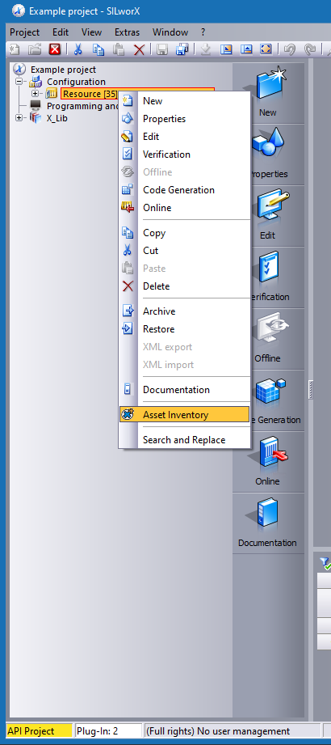
Figure 1: Resource context menu with menu entry for the plug-in

After starting, the window with the drop-down menu opens. Select any module or all modules from the drop-down menu to read out the diagnostic data of a specific module or the diagnostic data of all modules.

The following options can also be selected via this window:

- all: Reads out all categories of the diagnostic data
- userinfo: Reads out user information
- usererr: Reads out user errors
- userwarn: Reads out user warnings
- interninfo: Reads out internal information
- internerr: Reads out internal errors

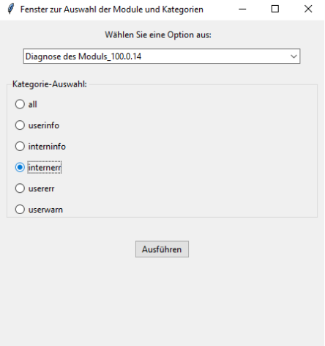

Figure 2: Module and category selection window

To do this, it executes the following SILworX actions one after the other:

- Retrieving the date and time of the diagnostic readout
- Retrieving product name, version and license via the Help, About SILworX menu
- Retrieving project name, configuration and resource from the structure tree
- Retrieving of System ID via the Extras, Properties of the selected resource menu
- Execution a system login with access type "Read" via the Extra, Online of the selected resource menu
- Retrieving the hardware module information via the Online, module data overview menu of the connected resources and calculation of the number of available modules
- Read out the diagnostic data for any selected modules and categories
- Saves the read-out diagnostic data in an Excel file
- Disconnect the online session of the connected resource via the Online , Disconnect menu

During data recording, the plug-in displays a message indicating that the actions are being carried out.
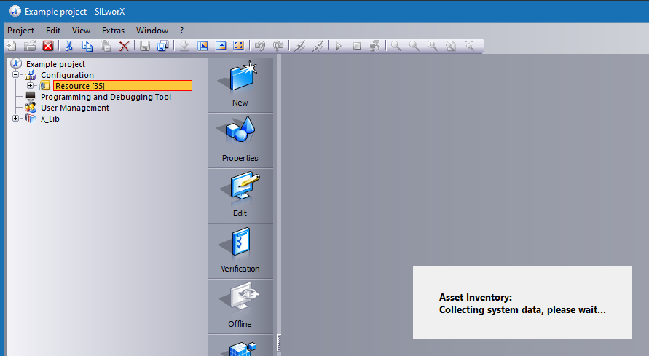
Figure 3: Feedback message of the plug-in
If the SILworX project has a user management, the plug-in cannot perform a system login with the default login credentials. In this case, the plug-in requests the login data for the controller via a dialog.
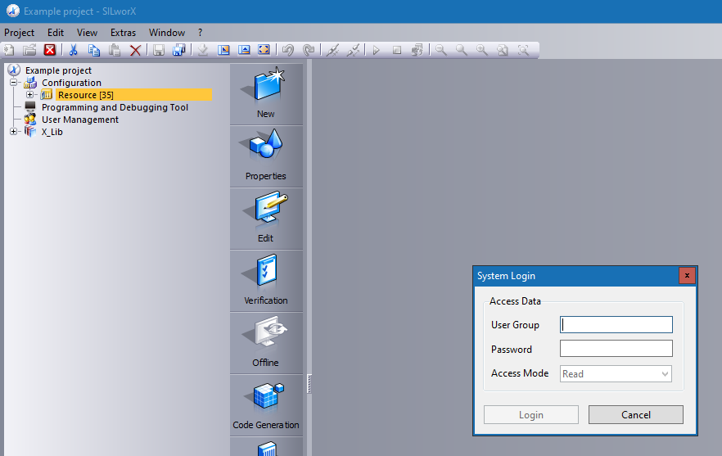
Figure 4: Login dialog of the plug-in for the system login

Once all inventory data has been retrieved, another dialog box appears to save the data in CSV format.
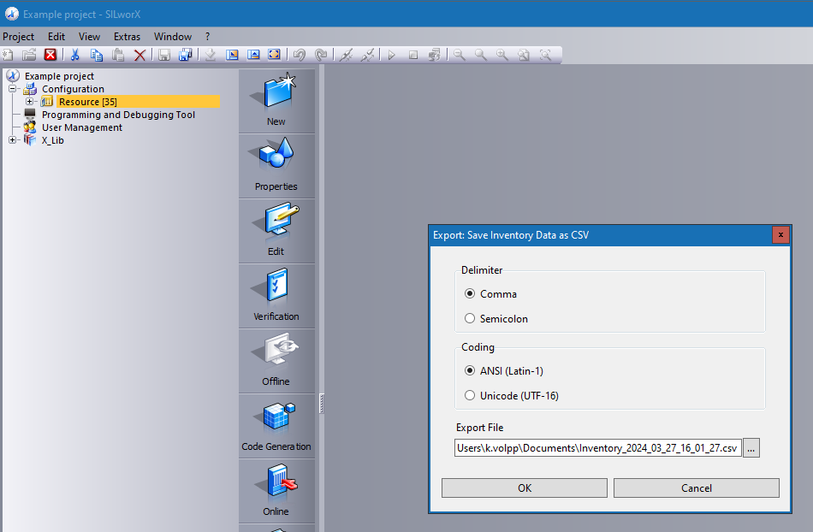
Figure 5: Dialog box of the plug-in for saving the diagnostic data

By default, the CSV file is stored in the user directory %UserProfile%\Documents\ under the name "Inventory_yyyy_mm_dd.csv", where "yyyy_mm_dd" corresponds to the date plug-in was started. The CSV file contains the information shown below as an example in tabular form, which can be further processed with any spreadsheet program or database system.
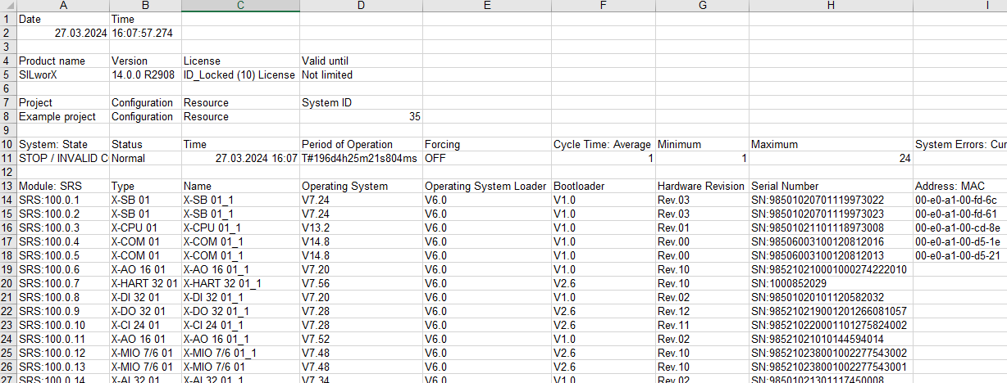
Figure 6: Section of an example with the diagnostic data from the csv file

Appendix

Glossary
Term | Description
SILworX | Programming tool for HIMax, HIQuad X and HIMatrix
API | Application Programming Interface
HTTPS | Hypertext Transfer Protocol Secure, communication protocol
SSL | Secure Sockets Layer, deprecated ancestor of TLS
TLS | Transport Layer Security, cryptographic protocol
PEM | Privacy Enhanced Mail, file format according RFC 7468
RSA | Rivest–Shamir–Adleman, public-key cryptosystem
localhost | In computer networking, localhost is the hostname of the current computer
SHA | Secure Hash Algorithm, cryptographic hash function
JSON | JavaScript Object Notation, file format according RFC 8259
CSV | Comma-Separated Values, file format according RFC 4180
Index of Figures
Figure 1: Resource context menu with menu entry for the plug-in 12
Figure 2: Module and category selection window 13
Figure 3: Feedback message of the plug-in 14
Figure 4: Login dialog of the plug-in for the system login 14
Figure 5: Dialog box of the plug-in for saving the diagnostic data 15
Figure 6: Section of an example with the diagnostic data from the csv file 15

